République Algérienne Démocratique et Populaire

Ministère de l’Enseignement Supérieur et de la Recherche Scientifique

Université des Sciences et de la Technologie Houari Boumediene



Faculté d’Informatique

Final Project TIC

**INFORMATION AND COMMUNICATION TECHNOLOGIES**

**Groupe n°9 :**

- BOUKHEDOUNI Nada Raiham (Sec A – Gr 2)

- CHAMI Sara (Sec A – Gr 3)

- EL ALLIA Noor EL Houda (Sec A – Gr 2)

- CHAIB Aya Sofia (Sec A – Gr 3)

- BENBRIKA Chaima (Sec A – Gr 2)

**Proposé par :**

Mr BOUCHEKIR Redouane

**Date de remise :**

06 Janvier 2024

Année universitaire 2023 – 2024

**Table of contents**

1. Introduction 1

2. What are the components of TIC? 2

3. Technologies related to TIC 3

4. Conclusion 10

5. Références Bibliographiques 11

# Introduction

The term “*Information and Communications Technologies* (TIC)” is used to delineate the various Telecommunications and Information Technologies, which have been used in the field of transport since the mid-80s [1].

TIC, or information and communications technology (or technologies), is the [infrastructure](https://www.techtarget.com/searchdatacenter/definition/infrastructure) and [components](https://www.techtarget.com/whatis/definition/component) that enable modern computing. Among the goals of IC technologies, tools and [systems](https://www.techtarget.com/searchwindowsserver/definition/system) is to improve the way humans create, process and share [data](https://www.techtarget.com/searchdatamanagement/definition/data) or information with each other. Another is to help them improve their abilities in numerous areas, including business; education; medicine; real-world problem-solving; and even leisure activities related to sports, music, and movies.

Information and communication technologies (TIC) refer to the technologies and tools used to process, store, transmit, and retrieve information. They play a crucial role in our modern world, facilitating communication, data management, and access to information.

TIC encompasses a wide range of technologies, including computers, software applications, networks, the internet, mobile devices, and telecommunications systems.These technologies enable us to communicate instantly across the globe, access vast amounts of information, and perform various tasks efficiently.

With TIC, we can send emails, make video calls, share fails, and collaborate with others remotely. It has transformed the way we work, learn, and interact with the world. TIC has also revolutionized industries such as healthcare finance, education, and entertainment, making processes more efficient and accessible.

Information and communication technologies (TIC) is defined as a diverse set of technological tools and resources used to transmit, store, create, share or exchange information. These technological tools and resources include computers, the Internet (websites, blogs and emails), live broadcasting technologies (radio, television and webcasting), recorded broadcasting technologies (podcasting, audio and video players, and storage devices) and telephony (fixed or mobile, satellite, visio/video-conferencing, etc.). It has became an integral part of our daily lives, enhancing communication, productivity, and connectivity.

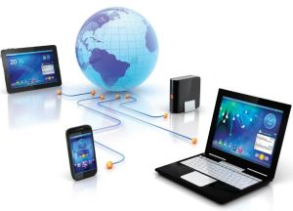

# What are the components of TIC?

Any technology, infrastructure, component, or device that enables communications, data sharing, and global connectivity between humans and between humans and machines is included in the umbrella term TIC.

The components include the following:

* Devices (hardware).
* Software.
* Data.
* Communication technologies.
* Communications protocols and interfaces
* The cloud.
* Information security and governance policies.

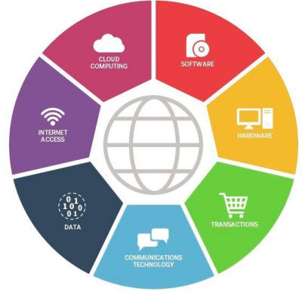

ICT means more than its list of components. It encompasses the application of all those various components.

# Technologies related to TIC

* 1. Google services

Google offers a wide range of services, including the popular search engine, Google Search.it is a powerful tool for finding information on the web. They also have other services like Gmail for email, google maps for navigation, and Google Drive for cloud storage, Google documents for creating and editing documents online, Google sheets for organizing data, creating formulas, and performing calculations, Google meet a video conferencing platform, Google slides and many other services.

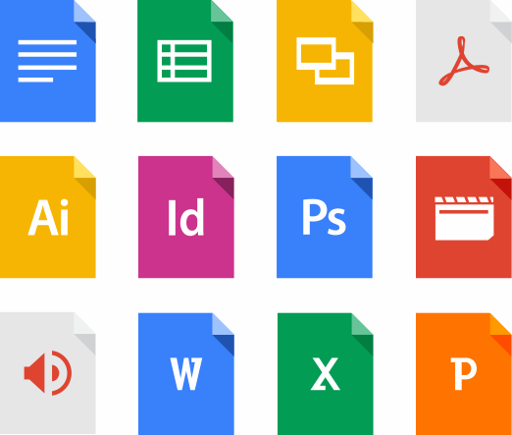

* **Gmail**

Gmail is a free web-based [email](https://www.techtarget.com/whatis/definition/e-mail-electronic-mail-or-email) service that provides users with 15[GB](https://www.techtarget.com/searchstorage/definition/gigabyte) of storage for messages and the ability to search for specific messages.

The Gmail program also automatically organizes successively related messages into a conversational thread.

Born in 2004, Google Gmail initially emerged as an internal communication service among Google employees. When it launched for the standard consumer, Google made a strong bet by offering 1GB of free storage which was much higher than what most email services offered at the time. Taking into account this feature, and although in principle Gmail could only be accessed through invitations from other registered users, the service was popularized quickly,being fully accessible from 2007 and arriving in 2012 to surpass Outlook (Microsoft’s email service) thus becoming email most used worldwide with the overwhelming figure of 1,500 million accounts registered in 2018.

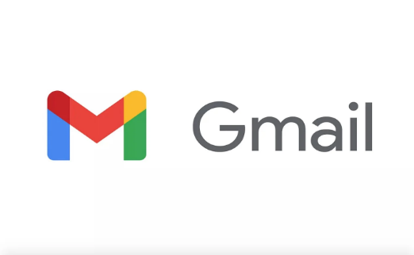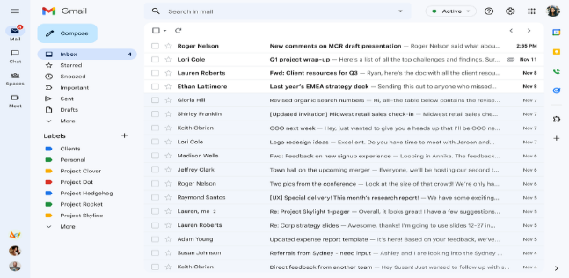

Here some informations about Gmail:[1]

|  |  |
| --- | --- |
| Launch date | April 1, 2004 |
| Founder | Paul Buchheit (Google developer) |
| Headquarters | Mountain view, California |
| Parent company | Google |
| Number of active users | More than 1.8 billion |
| Number of emails sent every day | 121 billion emails sent through Gmail |
| Email client market share | 28.78% |
| Supported languages | 105 languages |

* **Google drive**

Google Drive is a free Google file storage service in the cloud. Launched in 2012 to replace Google Docs, which only had 1GB of storage, it meant a wide increase in capacity for users reaching up to 15GB completely free. In addition, Google Drive incorporates various applications such as a spreadsheet program, a program to create presentations and a text editing program.

Google Drive features:

* **File Storage**: 15 GB of free storage expandable up to 200TB at different rates
* **Document creation**: through Google Docs, which is integrated into Drive, we can create text files, presentations and spreadsheets
* **Connectivity**: Google Drive is designed so that we can easily share our files with the user we wan
* **Integrated apps**: in addition to the aforementioned tools to create documents, drive has hundreds of compatible applications of all kinds, which we can install from the Chrome Web Store.

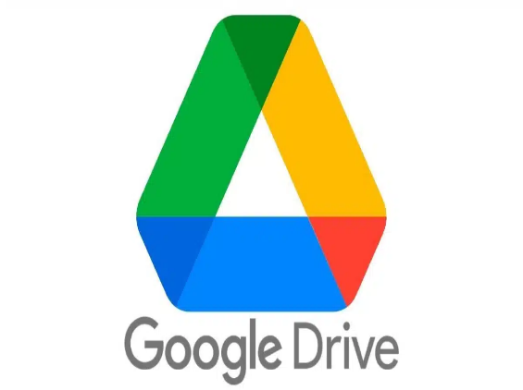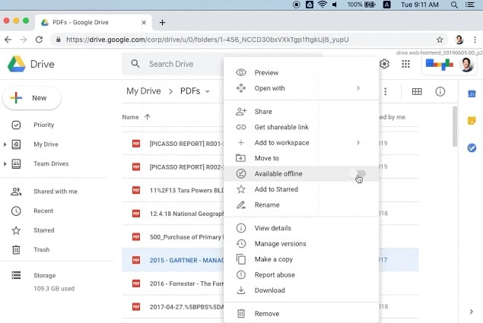

* **Google sheets**

Google Sheets is a spreadsheet application included as part of the free, web-based Google Docs Editors suite offered by Google. Google Sheets is available as a web application, a mobile app for: Android, iOS, and as a desktop application on Google's ChromeOS. The app is compatible with Microsoft Excel file formats. The app allows users to create and edit files online while collaborating with other users in real-time.

Features of Google Sheets:

* **Editing:** One of the key features of Google Sheets is that it allows collaborative editing of spreadsheets in real-time. Rather than emailing one document to multiple people, a single document can be opened and edited by multiple users simultaneously. Users can see every change made by other collaborators, and all changes are automatically saved to Google servers.
* **Explore:** The Explore feature in Google Sheets was first introduced in September 2016, and it uses machine learning to bring additional functionalities. This feature provides a lot of information based on the data added to the spreadsheet, and it can auto-update itself depending on the selected data.
* **Offline editing:** Google Sheets supports offline editing, and users can edit the spreadsheet offline either on desktop or mobile apps.
* **Integration with other Google products:** Google Sheets can be integrated with other Google products such as Google Form, Google Finance, Google Translate, and Google Drawings.

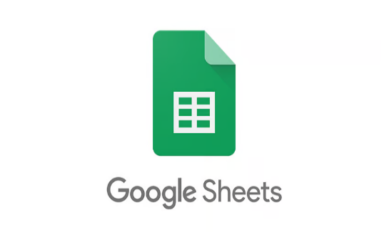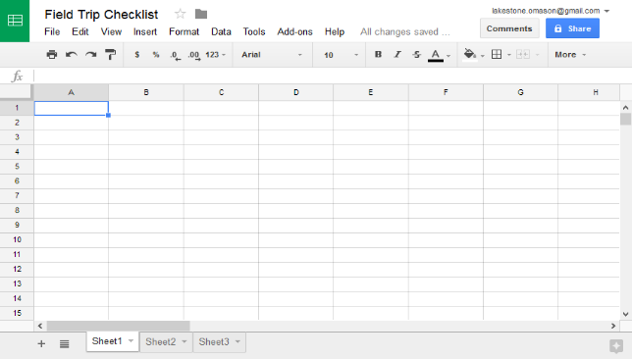

* 1. Microsoft tools

Microsoft offers a wide range of tools that are widely used in various fields. One of the most well-known tools is Microsoft office, which includes programs like Word, Excel, and PowerPoint. Word is a word processing software used for creating and editing documents, while Excel is a powerful spreadsheet program for organizing and analyzing data. PowerPoint is a presentation tool that allows you to create visually appealing slideshows. Microsoft also offers other tools like Outlook for email and calendar management, Teams for collaboration and communication, and OneDrive or cloud storage. These tools are widely used in both personal and professional settings.

* **Microsoft office**

Microsoft Office is a suite of applications designed to help with productivity and completing common tasks on a computer. You can create and edit documents containing text and images, work with data in spreadsheets and databases, and create presentations and posters.

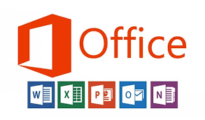

* **Microsoft Word**

Microsoft Word or MS Word (often called Word) is a graphical word processing program that users can type with. It is made by the computer company Microsoft. Its purpose is to allow users to type and save documents.

**What can you do with Microsoft Word ?**

* Use the traditional options like copy, cut and paste.
* Insert pictures from your hard drive or from the web right from the Microsoft Word Insert Tool Bar.
* Open and edit PDF files.
* Add headers and footers, and page formatting.

Microsoft Word versions:[2]

|  |  |
| --- | --- |
| Ms version | Date |
| Word for Windows 95 (sometimes called Word 7) | 1995 |
| Word 97 (sometimes called Word 8) | 1997 |
| Word 2000 (sometimes called Word 9) | 1999 |
| Word 2002 (sometimes called Word 10 or Word XP) | 2001 |
| Word 2007 | 2007 |
| Word 2019 | 2019 |
| Word 2021 | 2021 |

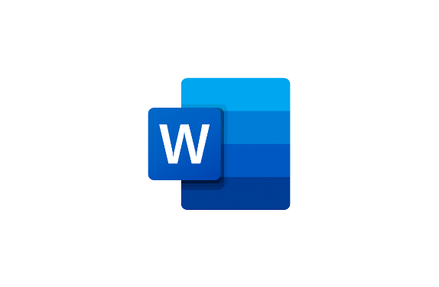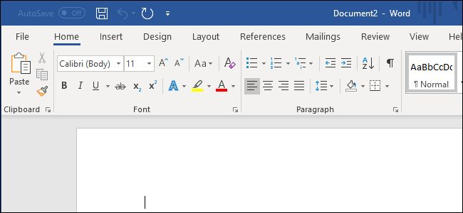

* **Microsoft Excel**

A software program created by Microsoft that uses spreadsheets to organize numbers and data with formulas and functions. Excel analysis is ubiquitous around the world and used by businesses of all sizes to perform financial analysis

**What is Excel used for ?**

* Data entry
* Data management
* Accounting
* Financial analysis
* Charting and graphing
* Programming
* Time & task management
* Costumer relationship management

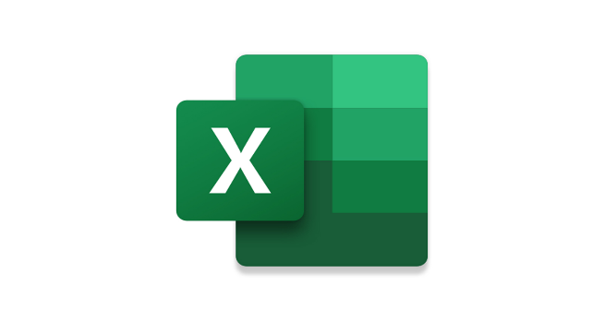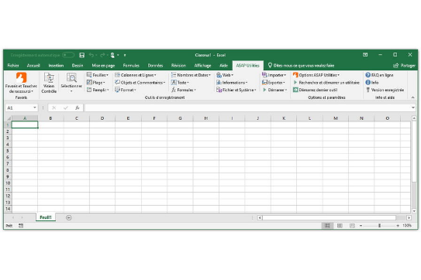

* **Microsoft PowerPoint**

MS PowerPoint is a program that is included in the Microsoft Office suite. It is used to make presentations for personal and professional purposes. The program uses slides to convey information rich in multimedia and is used to create complex business presentations, simple educational outlines and much more. It is an absolute presentation graphics package that gives you everything needed to create a professional-looking presentation. PowerPoint offers word processing, drawing, outlining, graphing, and presentation management tools.

**Features of MS PowerPoint**

* Home: in PowerPoint, there are slides. Users need to add content to them to make a presentation
* Insert: the user can add media like pictures, symbols, audio, video, header, footer
* Design: The design menu offers the user with ready-made templates & background designs for slides
* Slideshow: from the Slideshow menu, the user can view the final form of the slideshow
* Animations: During the slide show, the slides emerge on the screen one after the other. In case, one desires to add some animations to how a slide displays itself, they can refer to the “Animations” category.

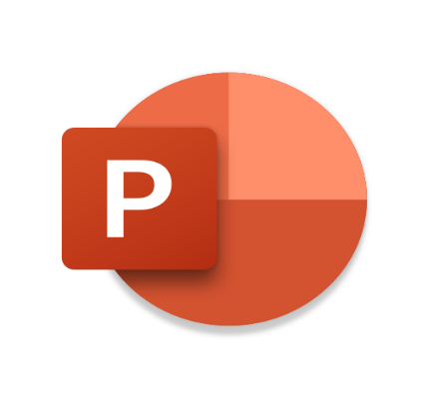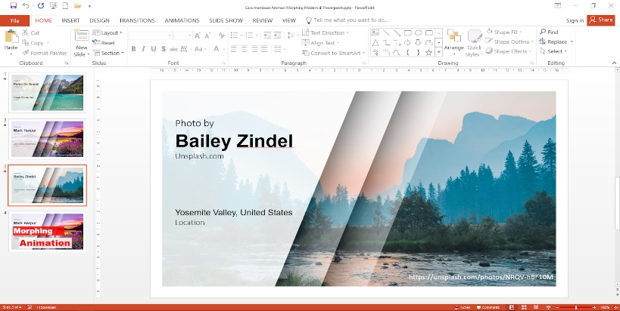

* **Microsoft outlook**

Microsoft Outlook is a part of Office Suite that can be used as a standalone application. It helps you to access Microsoft Exchange Server email. Additionally, it provides contacts, calendaring, and task management functionality.

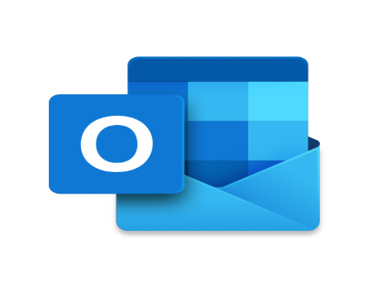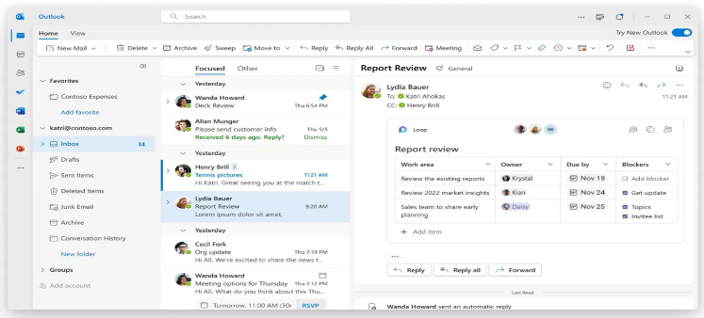

* 1. Latex

Latex is a high-quality typesetting system, it includes features designed for the production of technical and scientific documentation .Latex is the de facto standard for the communication and publication of scientific documents. Latex is available as free software .LaTex is a package that allows users to use the TeX typesetting program as the formatting engine. TeX typesetting is designed to document complex mathematical notations, text and formulas. That is why LaTeX is best suited for technical journals, reports, books and slide presentations.

A LaTeX input file can be written in a text editor. This input file will contain text and commands for formatting. A LaTeX user would have to specify the structure of the document. When viewing a LaTeX input in its raw text form, the markup commands, like those found in HTML documents, can be viewed. However, backward slashes and curly brackets are used in a LaTeX input file instead of angle brackets.

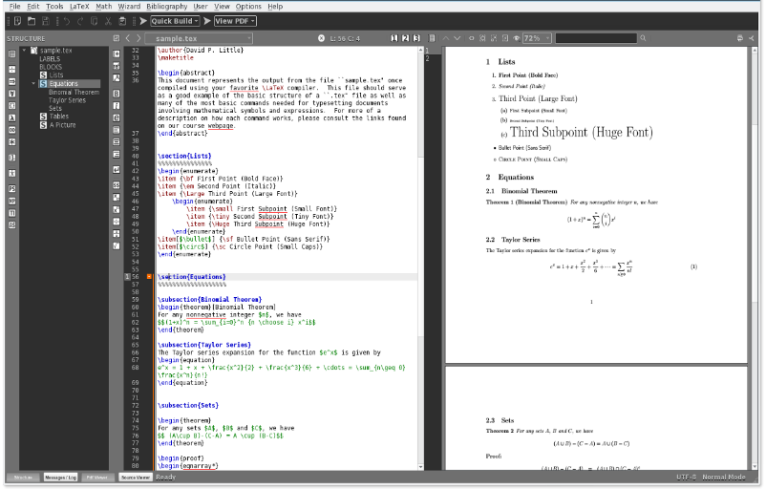

* 1. Git & Github
* **Git**

Git, a version control system for software development, ensures developers can revert back to specific past versions of their work to see records of work completed and allows for streamlined collaboration by permitting changes made by multiple people to be merged into one location. Git is a content management and tracking system developed by Linus Torvalds, creator of Linux. It includes a directory that continuously changes as codes are added throughout application or website development. Git also tracks revisions that are performed on stored data.

Git is simple, flexible and easily sharable by various project or team participants

Designed for speed, Git minimizes resources related to product and Web development – even with massive projects. For example, rather than starting a project from scratch, a developer can retrieve and change stored codes to maximize efficiency.

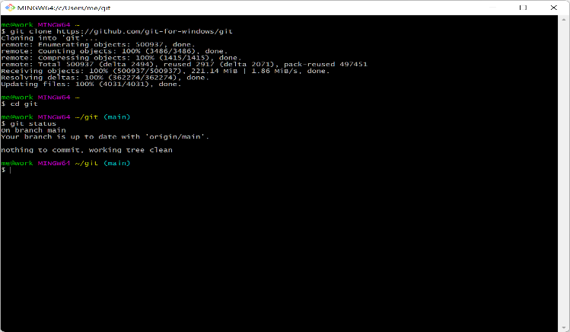

* **GitHub**

GitHub is a for-profit company that offers a cloud-based Git repository hosting service. Essentially, it makes it a lot easier for individuals and teams to use Git for version control and collaboration.

GitHub interface is user-friendly enough so even novice coders can take advantage of Git. Without GitHub, using Git generally requires a bit more technical savvy and use of the command line.

GitHub is so user-friendly, though, that some people even use GitHub to manage other types of projects (like writing books).

Additionally, anyone can sign up and host a public code repository for free, which makes GitHub especially popular with open-source projects.

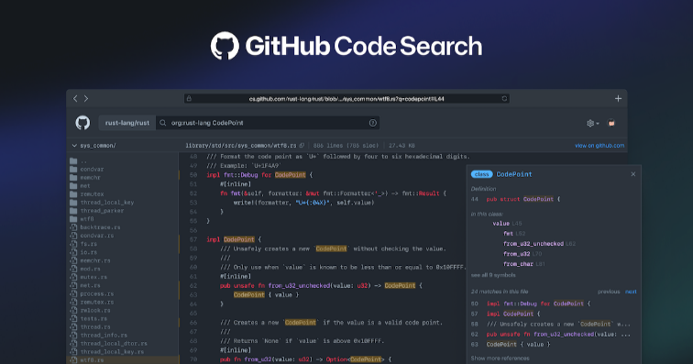

Using Git and GitHub together can greatly enhance the efficiency and productivity of software development teams.it is a powerful combination for version control and collaborative coding.

# Conclusion

Information and communication technologies (TIC) have revolutionized the way we communicate, access information, and conduct various activities. They have greatly enhanced our ability to connect with others, share knowledge, and streamline processes. With the advent of smartphones, social media, and the internet, we now have instant access to vast amount of information at our fingertips.

TIC has transformed various industries, including business, education, healthcare, and entertainment. It has made remote work and online learning more accessible and efficient. Communication tools like email, messaging apps, and video conferencing platforms have bridged the gap between individuals and allowed for seamless collaboration, regardless of geographical location.

Overall, TIC has transformed the way we live, work, and interact with the world around us. It has revolutionized communication, improved access to information, and accelerated progress in various fields. As we continue to embrace and adapt to these technologies, it is important to harness their potential for positive change while addressing any associated challenges.

# Références Bibliographiques

[1] Techtarget :information and communication technologies

<https://www.techtarget.com/searchcio/definition/ICT-information-and-communications-technology-or-technologies>

ScienceDirect :the application of information and communication technologies in transport

<https://www.sciencedirect.com/science/article/abs/pii/S0377221703000262>

Unesco IIEP Learning Portal: information and communication technologies

<https://learningportal.iiep.unesco.org/en/glossary/information-and-communication-technologies-ict>

Techopedia: information and communication technology (Margaret Rouse technology expert)

<https://www.techopedia.com/definition/24152/information-and-communications-technology-ict>

Techopedia : Microsoft word (Margaret Rouse technology expert)

<https://www.techopedia.com/definition/3840/microsoft-word>

Wikipedia: Microsoft word <https://en.wikipedia.org/wiki/Microsoft_Word>

University of Arkansas at little rock: Microsoft word information technology services

<https://ualr.edu/itservices/applications/v/microsoft-word/>

University of York :Microsoft office essentials <https://subjectguides.york.ac.uk/it-essentials/office>

Testbook: Microsoft PowerPoint introduction

<https://testbook.com/computer-awareness/microsoft-powerpoint>

Wikipedia :Microsoft outlook <https://en.wikipedia.org/wiki/Microsoft_Outlook>

Techopedia :what is Git (Margaret Rouse technology expert)

Techopedia : what is Latex (Margaret Rouse technology expert) <https://www.techopedia.com/definition/28960/git#:~:text=Git%20is%20a%20content%20management,Linus%20Torvalds%2C%20creator%20of%20Linux>.

ARIMETRICS: what is google drive? <https://www.arimetrics.com/en/digital-glossary/google-drive>

Corporate finance institute: Google sheets <https://corporatefinanceinstitute.com/resources/excel/google-sheets/>

Demandsage: Gmail statistics for 2024 <https://www.demandsage.com/gmail-statistics/>

Techtarget: what is gmail <https://www.techtarget.com/whatis/definition/Gmail#:~:text=Gmail%20(pronounced%20Gee%2Dmail),to%20search%20for%20specific%20messages>.

The LATEX project: a document preparation system <https://www.latex-project.org/>

Corporate finance institute: EXCEL definition <https://corporatefinanceinstitute.com/resources/excel/excel-definition-overview/>

BYJU`s EXAM PREP : an introduction to Ms PowerPoint

<https://byjus.com/govt-exams/microsoft-powerpoint/>

Builtin: what is Git <https://builtin.com/software-engineering-perspectives/git>

TechTarget : what is GitHub <https://www.techtarget.com/searchitoperations/definition/GitHub#:~:text=GitHub%20is%20a%20web%2Dbased,for%20%247.5%20billion%20in%202018>.

Kinsta : what is GitHub? A beginner`s introduction to GitHub

<https://kinsta.com/knowledgebase/what-is-github/#:~:text=At%20a%20high%20level%2C%20GitHub,Version%20control>

1. Demandstage :Gmail statistics for 2024

   <https://www.demandsage.com/gmail-statistics/>
2. wikipedia: Microsoft Word

   <https://en.wikipedia.org/wiki/Microsoft_Word#File_formats>